

Institute Name – Itvedant Education Pvt. Ltd

Name: Priti Yadav

Project Name: Hospital Management System

Project Guide: Prof. Sameer Warsolkar





* 1. **Project for SQL Module:**

A Hospital Management System (HMS) is a comprehensive software solution designed to streamline and automate the day-to-day operations and management of a healthcare facility. It encompasses a wide range of functionalities to improve efficiency, enhance patient care, and ensure smooth administration within a hospital or medical institution. Below is a description of key components and features typically found in a Hospital Management System:

**Core Modules and Features:**

1. **Patient Management:**

* Patient Registration: Capture and store patient information, including personal details, medical history, and contact information.
* Appointment Scheduling: Facilitate the scheduling and management of patient appointments with doctors and other healthcare providers.

1. **Doctor and Staff Management:**

* **Doctor Information**: Maintain records of doctors, including their specialties, contact details, and schedules.
* **Staff Information:** Manage information about other hospital staff, such as nurses, administrative personnel, and technicians.

1. **Appointment and Queue Management:**

* **Appointment Booking:** Allow patients to book appointments online or through the hospital.
* **Queue Management:** Streamline patient flow with an organized queue system.

1. **Medical Records Management:**

* **Electronic Health Records (EHR):** Digitize and store patient medical records, including diagnoses, treatments, and prescriptions.
* **Diagnostic Reports:** Capture and manage results of various diagnostic tests and imaging procedures.

1. **Billing and Invoicing:**

* **Billing and Invoicing:** Generate bills for medical services rendered, including consultations, treatments, and tests.
* **Insurance Integration:** Manage insurance claims and integrate with insurance systems for seamless billing processes.

1. **Inventory Management:**

* **Medicine and Equipment Inventory:** Track and manage the hospital's inventory of medicines, medical supplies, and equipment.
* **Supplier Management**: Keep records of suppliers and automate reordering processes.

1. **Reporting and Analytics:**

* **Data Analysis**: Generate reports on various aspects of hospital operations, patient outcomes, and financial performance.
* **Business Intelligence:** Use analytics to make informed decisions and optimize hospital processes.
  1. **ER-Diagram (Entity Relation – Diagram) for hospital Management System:**

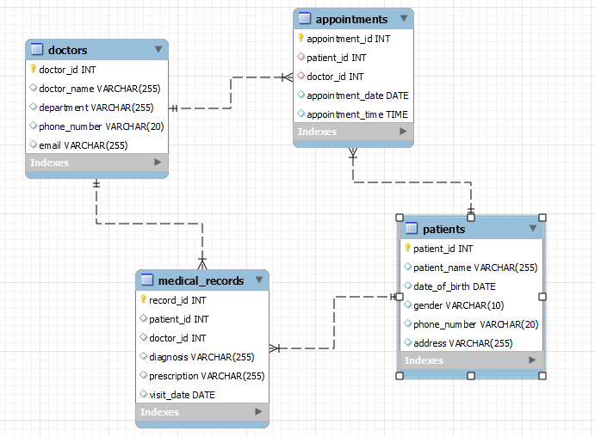

* 1. **Table Descriptions:**

1. TABLE Patients:

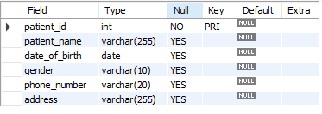

1. TABLE Doctors:

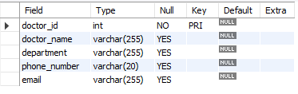

1. TABLE appointments:

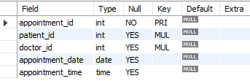

1. TABLE medical_records:

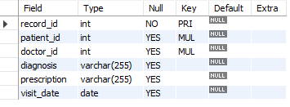

* 1. **COMMANDS:**

Create Database:

create database hospital_management;

use hospital_management;

Create table named patients:

CREATE TABLE patients (

patient_id INT PRIMARY KEY,

patient_name VARCHAR(255),

date_of_birth DATE,

gender VARCHAR(10),

phone_number VARCHAR(20),

address VARCHAR(255)

);

desc patients;

Create table named doctors:

CREATE TABLE doctors (

doctor_id INT PRIMARY KEY,

doctor_name VARCHAR(255),

department VARCHAR(255),

phone_number VARCHAR(20),

email VARCHAR(255)

);

desc doctors;

Create table named appointments:

CREATE TABLE appointments (

appointment_id INT PRIMARY KEY,

patient_id INT,

doctor_id INT,

appointment_date DATE,

appointment_time TIME,

FOREIGN KEY (patient_id) REFERENCES patients(patient_id),

FOREIGN KEY (doctor_id) REFERENCES doctors(doctor_id)

);

desc appointments;

Create table named medical_records:

CREATE TABLE medical_records (

record_id INT PRIMARY KEY,

patient_id INT,

doctor_id INT,

diagnosis VARCHAR(255),

prescription VARCHAR(255),

visit_date DATE,

FOREIGN KEY (patient_id) REFERENCES patients(patient_id),

FOREIGN KEY (doctor_id) REFERENCES doctors(doctor_id)

);

desc medical_records;

INSERT INTO patients (patient_id, patient_name, date_of_birth, gender, phone_number, address) VALUES

(1, 'John Doe', '1980-01-01', 'Male', '123-456-7890', '123 Main St'),

(2, 'Jane Smith', '1985-05-10', 'Female', '456-789-0123', '456 Oak Ave'),

(3, 'Michael Johnson', '1972-09-15', 'Male', '789-012-3456', '789 Maple Rd'),

(4, 'Emily Williams', '1992-03-20', 'Female', '987-654-3210', '987 Cedar Lane'),

(5, 'William Brown', '1988-11-05', 'Male', '567-890-1234', '567 Pine Street'),

(6, 'Mary Johnson', '1982-07-22', 'Female', '234-567-8901', '234 Elm St'),

(7, 'David Wilson', '1990-09-30', 'Male', '345-678-9012', '345 Birch Rd'),

(8, 'Sarah Davis', '1987-04-14', 'Female', '456-789-0123', '456 Cedar Ln'),

(9, 'Robert Smith', '1975-12-05', 'Male', '567-890-1234', '567 Oak Ave'),

(10, 'Linda Miller', '1983-03-18', 'Female', '678-901-2345', '678 Pine St');

INSERT INTO doctors (doctor_id, doctor_name, department, phone_number, email) VALUES

(1, 'Dr. Patel', 'Cardiology', '111-222-3333', 'drpatel@example.com'),

(2, 'Dr. Garcia', 'Pediatrics', '222-333-4444', 'drgarcia@example.com'),

(3, 'Dr. Nguyen', 'Orthopedics', '333-444-5555', 'drnguyen@example.com'),

(4, 'Dr. Kim', 'Neurology', '444-555-6666', 'drkim@example.com'),

(5, 'Dr. Gupta', 'Oncology', '555-666-7777', 'drgupta@example.com'),

(6, 'Dr. Lewis', 'Dermatology', '666-777-8888', 'drlewis@example.com'),

(7, 'Dr. Turner', 'ENT', '777-888-9999', 'drturner@example.com'),

(8, 'Dr. Carter', 'Psychiatry', '888-999-0000', 'drcarter@example.com'),

(9, 'Dr. Hall', 'Urology', '999-000-1111', 'drhall@example.com'),

(10, 'Dr. Foster', 'Ophthalmology', '111-222-3333', 'drfoster@example.com');

INSERT INTO appointments (appointment_id, patient_id, doctor_id, appointment_date, appointment_time) VALUES

(1, 1, 1, '2023-11-01', '10:00:00'),

(2, 2, 2, '2023-11-02', '11:00:00'),

(3, 3, 3, '2023-11-03', '12:00:00'),

(4, 4, 4, '2023-11-04', '13:00:00'),

(5, 5, 5, '2023-11-05', '14:00:00'),

(6, 6, 6, '2023-11-06', '15:00:00'),

(7, 7, 7, '2023-11-07', '16:00:00'),

(8, 8, 8, '2023-11-08', '17:00:00'),

(9, 9, 9, '2023-11-09', '18:00:00'),

(10, 10, 10, '2023-11-10', '19:00:00');

INSERT INTO medical_records (record_id, patient_id, doctor_id, diagnosis, prescription, visit_date) VALUES

(1, 1, 1, 'Hypertension', 'Medication A', '2023-11-01'),

(2, 2, 2, 'Common cold', 'Rest and fluids', '2023-11-02'),

(3, 3, 3, 'Fractured arm', 'Pain medication', '2023-11-03'),

(4, 4, 4, 'Migraine', 'Prescription B', '2023-11-04'),

(5, 5, 5, 'Cancer treatment', 'Chemotherapy', '2023-11-05'),

(6, 6, 6, 'Skin allergy', 'Topical ointment', '2023-11-06'),

(7, 7, 7, 'Ear infection', 'Antibiotics', '2023-11-07'),

(8, 8, 8, 'Anxiety', 'Counseling', '2023-11-08'),

(9, 9, 9, 'UTI', 'Antibiotics', '2023-11-09'),

(10, 10, 10, 'Cataracts', 'Surgery recommended', '2023-11-10');

* 1. **SUBQUERIES:**

1. Find the names and contact details of patients who have appointments with doctors in the 'Pediatrics' department.

SELECT patient_name, phone_number, address

FROM patients

WHERE patient_id IN (

SELECT patient_id

FROM appointments

WHERE doctor_id IN (

SELECT doctor_id

FROM doctors

WHERE department = 'Pediatrics'

)

);

**Output:**



1. Retrieve the names of doctors who have appointments on '2023-11-03'.

SELECT doctor_name

FROM doctors

WHERE doctor_id IN (

SELECT doctor_id

FROM appointments

WHERE appointment_date = '2023-11-03'

);

Output:



1. List the names of patients who have medical records with a diagnosis of 'Cancer treatment'.

SELECT patient_name

FROM patients

WHERE patient_id IN (

SELECT patient_id

FROM medical_records

WHERE diagnosis = 'Cancer treatment'

);

Output:



1. Retrieve the names of patients who have appointments with doctors in the 'Cardiology' department and were diagnosed with 'Hypertension'.

SELECT patient_name

FROM patients

WHERE patient_id IN (

SELECT patient_id

FROM appointments

WHERE doctor_id IN (

SELECT doctor_id

FROM doctors

WHERE department = 'Cardiology'

)

AND patient_id IN (

SELECT patient_id

FROM medical_records

WHERE diagnosis = 'Hypertension'

)

);

Output:



* 1. **JOINS:**

1.Retrieve the names of patients along with their appointment details (date and time) and the corresponding doctor names.

SELECT patients.patient_name, appointments.appointment_date, appointments.appointment_time, doctors.doctor_name

FROM patients

JOIN appointments ON patients.patient_id = appointments.patient_id

JOIN doctors ON appointments.doctor_id = doctors.doctor_id;

Output:

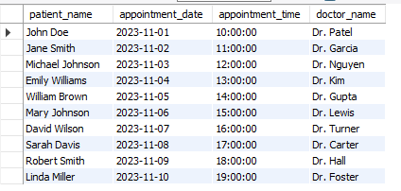

2.List the names of patients along with their medical records (diagnosis and prescription) and the corresponding doctor names.

SELECT patients.patient_name, medical_records.diagnosis, medical_records.prescription, doctors.doctor_name

FROM patients

JOIN medical_records ON patients.patient_id = medical_records.patient_id

JOIN doctors ON medical_records.doctor_id = doctors.doctor_id;

Output:

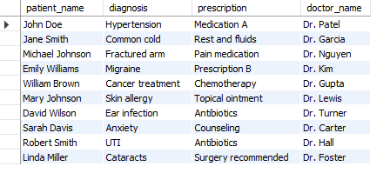

3.Retrieve the names of patients, their appointment details, and the corresponding department names.

SELECT patients.patient_name, appointments.appointment_date, appointments.appointment_time, doctors.department

FROM patients

JOIN appointments ON patients.patient_id = appointments.patient_id

JOIN doctors ON appointments.doctor_id = doctors.doctor_id;

Output:

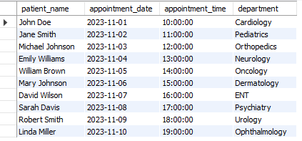

4.List the names of patients, their medical records, and the corresponding department names of the treating doctors.

SELECT patients.patient_name, medical_records.diagnosis, medical_records.prescription, doctors.department

FROM patients

JOIN medical_records ON patients.patient_id = medical_records.patient_id

JOIN doctors ON medical_records.doctor_id = doctors.doctor_id;

Output:

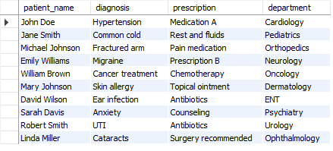

5.Retrieve the names of patients, their appointment details, and the corresponding department names, limiting the result to appointments on '2023-11-02' and beyond.

SELECT patients.patient_name, appointments.appointment_date, appointments.appointment_time, doctors.department

FROM patients

JOIN appointments ON patients.patient_id = appointments.patient_id

JOIN doctors ON appointments.doctor_id = doctors.doctor_id

WHERE appointments.appointment_date >= '2023-11-02';

Output:

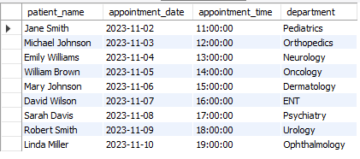

**Conclusion**

In summary, a well-implemented Hospital Management System serves as a foundational tool for healthcare institutions, helping them deliver efficient, high-quality care while addressing administrative challenges. By leveraging technology, hospitals can enhance their operational capabilities, improve patient outcomes, and adapt to the evolving landscape of healthcare services.

